Archdeaconry of Gibraltar Synod 2020: Caring for God’s Creation  Focusing on: Earth, Air, Fire and Water.  For since the creation of the world God’s invisible qualities - his eternal power and divine nature - have been clearly seen, being understood from what has been made, so that people are without excuse. Romans 1:20 |  |  | 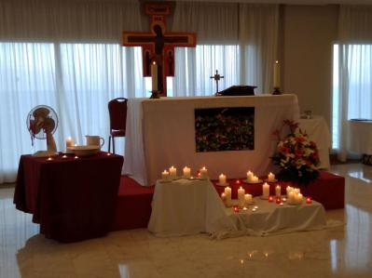
Bishop David celebrated and preached at the opening Eucharist on Tuesday evening where the theme was; For the Guidance of the Holy Spirit - Earth and Air. Two key points: the fingerprints of Jesus are in all creation and God made sprouts. Bishop David emphasizing the key points but with a sense of fun!
This was followed by the business meeting, where we were asked to longer refer to “Chaplaincy wardens” but to “church wardens”. Chaplaincies were asked to prepare welcoming information leaflets to welcome new chaplains and their families. We were also advised to keep an eye on the Diocesan website as it will be updated regularly:https://europe.anglican.org
The following two days began with Taize style worship, arranged by our very own Fr. Marcus.
A beautiful, peaceful, contemplative start to the days.
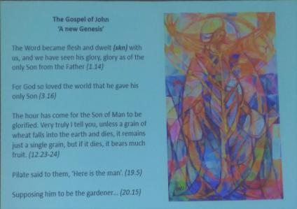 | The Bible studies: were lead by Dr. Clare Amos. The first study, Nature’s Poet focused on Psalm 104 not only reflecting on the beauty of God’s creation but also on the interface of God, Humanity and Creation.  The second study, Nature’s Priest focused on the words: ‘glory’,’image’, ‘transformed’, ‘creation’, ‘the glory of god in the face of Jesus Christ’ in reference to God and Jesus as teachers in harmony with the created world.
You could not have failed to be inspired by Revd. David Bookless, (Keynote speaker), speaking about A Rocha, ‘From Creation to New Creation’, the mission of God and a mission of God’s people.An environmental programme begun in Portugal and now spreading good environmental care news and methods worldwide looking at deforestation, single use plastic, climate related disasters etc. It was pointed out that: mission is God’s activity first and foremost, and that mission flows from the heart of the Trinity. |  |  | B - basic  I - instructions  B - before  L - leaving  E - earth
Consider the 5 ‘C’s’:  Creation:divine blessing - diversity,  Covenant:God’s response to a broken world (Noah)  Christ:Saviour of the world  Church:called to be Christ’s body  Consummation:new creation | “Sex! Why is this so complicated?” - Bishop David  If you require people to pay attention directly after lunch, then this did the trick! Bishop David guided us through this complex issue from the Book of Common Prayer and Canon 30 to the present day speaking about the Church of England’s approach to: marriage, divorce, partnerships, same sex marriage, celibacy. To discover the outcomes of many discussions over the years - look at the flowchart below.
There was a quick update by Damian Thwaites, Diocesan Communications Officer, on Brexit Residency applications. Basically, if you have not done this already, then do it soon! | 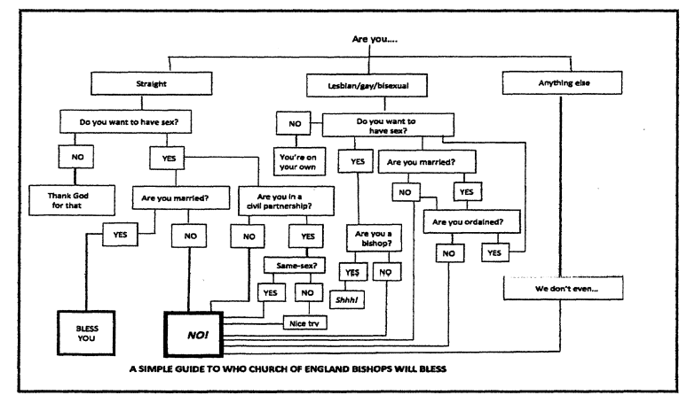
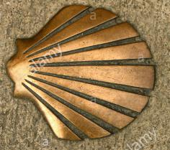Revd. Bob Bates spoke about the Chaplaincy of the Camino in Portugal. This is an active centre where pilgrims can take rest and share in communion.
An update from our link Diocese in Peru from Fr. Luis who spoke of the growing congregations and active worship centres. His pastoral care parish is Santa Maria Magdalena at 13,123 ft above sea level. He has both children’s and young peoples groups and he can be seen in the photos. | 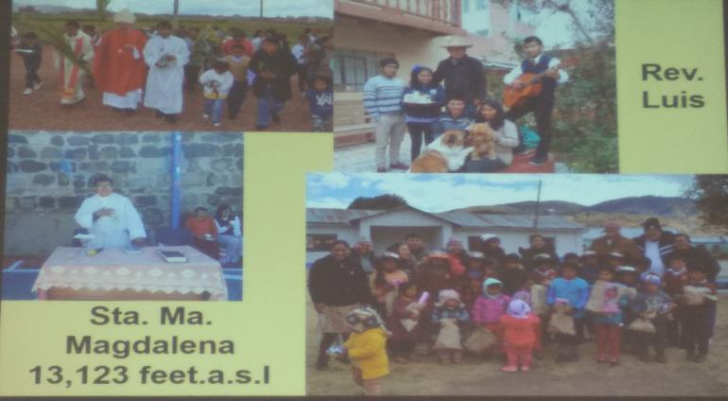
The Holy Eucharist on Wednesday evening was held in the local catholic church, a short walk away from the hotel. Revd. Dave Bookless preached on the theme of Wind and Fire
On Thursday morning there was an opportunity to meet in groups to share examples of good practice in our Chaplaincies and then report back to the meeting. We heard that Costa del Sol West go ‘plogging’ - picking up litter from the beach. Ibiza/Formentera have a family service. Malaga have developed a community concert space. Casablanca, through rotating the music style over a few Sundays, are able to involve their congregants in sharing the music of their cultures. Costa Azahar visit campsites. Almeria used hand crafted angels to advertise their Christmas events and services. Fuerteventura used reverse ‘Advent calendars’ during Advent and Lent, increasing their donations to food banks and charities.
Presentations from Diocesan Staff:
Chief Operating Officer, Andrew Caspari - this is the final year of payments to bring Diocesan finance up to date. There is some information to come on insurance for clergy. Information about how finances were used in the diocese were given.
Safeguarding Director, Grace Fagan - gave a very clear presentation about Safeguarding after only 8 weeks in post. There are investigations proceeding which involve 27 core groups and 2 police investigations. 500+ people have been trained at level 2 and the training is moving forwards to C5, a refresher course for those who were trained at Level 2 three years ago.
Environment Officer, Revd. Elizabeth Bussmann - the ECO church is the hope for the future each church being responsible for their actions. All chaplaincies should appoint an Environmental Officer who would be in contact with the Diocesan Environmental Officer.
Spanish section business:  Venerable David Waller is our new Archdeacon.  The budget has been agreed but not yet signed.  FEREDE, processing of clergy details is in progress.  Hopefully the Archdeaconry fees will be less.  Mileage allowance - €0.36 per km will remain the same |  | 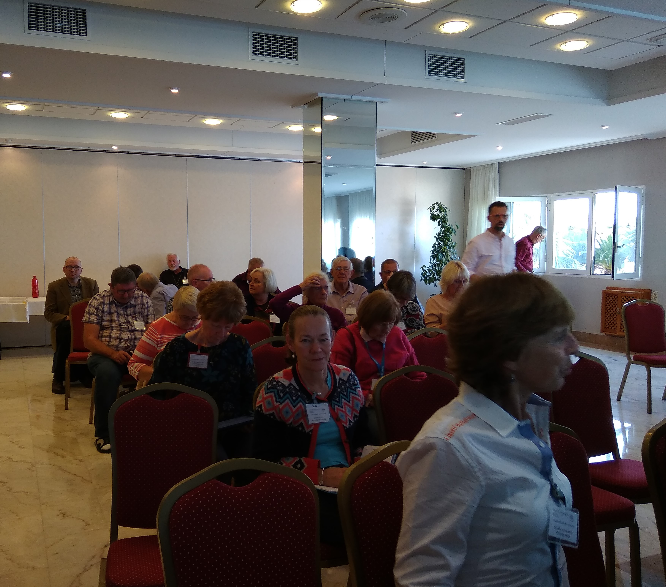
Holy Eucharist - Healing service - Water
Synod closed with a spiritually uplifting celebration of the Holy Eucharist including the sacrament of healing.
After supper, Canon Geoff Johnston gave his final report and a presentation was made on behalf of the Archdeaconry.  This was followed by a quiz and a very funny sketch staged by Bishop David (high church), David Coulston (middle of the road) and Joan Berry (low church). They gave a very amusing explanation and comparison of their differing styles of worship!! |  | 